ANNUAL EXAM [2022-23]
Class: IX [Information Technology] Date: 17/02/2023 Time: 2 hrs MM: 50
General Instructions:
- Please read the instructions carefully.
- This Question Paper consists two sections: Section A & Section B.
- Section A has Objective type questions where as Section B contains Subjective type questions.
- All questions of a particular section must be attempted in the correct order.
- Do as per the instructions given.
- Marks allotted are mentioned against each question/part.
SECTION A: OBJECTIVE TYPE QUESTIONS
Q:I Answer the following questions (1x4=4)
- People with low confidence are :
(a) Smart (b) Pleasant (c)Unprepared (d) Arrogant
2. People with self-confidence have a ___________outlook
(a) Negative (b) Arrogant (c) Outward (d) Positive
3. Chrome and Internet Explorer are popular __________.
- Websites (b) Search engines (c) Web browser (d) Internet service provider
4. The final output available to a user on the monitor is known as ________.
- Hardcopy (b) Software (c) Softcopy (d) Bytes
Q:II Answer the following questions (1x5=5)
1. An e-reader is capable of holding thousands of:
- Newspapers (b) E-books (c) Photos (d) Movies
2. What is the full form of BPM?
- Business Power Management (c) Business Process Management
- Basic Process Management (d) Basic Power Management
3. One can easily move an item from one location to another by using _____ action.
- Double-click (b) Click (c) Drag and Drop (d) Right-click
4. ___________ is a temporary storage location.
- Clipboard (b) Rulers (c) Ribbon (d) Tabs
5. What is the file extension of the word document?
- .docw (b) .docx (c) .dow (d) .docu
Q:III Answer the following questions (1x5=5)
- Which type of formatting focuses on the appearance of an individual character?
- Page (b) character (c) paragraph (d) all of these
- The numeric data can be converted into labels by formatting them as _______
- Numeral value (b) filter (c) chart (d) text
- From which menu can you insert a chart in your worksheet?
- Edit (b) format (c) insert (d) data
- The __________ checks the functioning of all the connected hardware, including primary and secondary storage devices.
- Booting Process (b) POST (c) Power On (d) Input Unit
- Which is the last valid column header in MS Excel?
- XFD (b) AJ (c) AZ (d) AJM
Q:IV Answer the following questions (1x5=5)
- Which key combination is used to open an existing presentation
- Ctrl + S (b) Ctrl + O (c) Ctrl + N (d) Ctrl + C
- The transition effects are available under the ____________tab.
- Transition (b) Slide show (c) Tools (d) Insert
- ________ Skill is the ability to use your time, energy and resources effectively to achieve goals.
- Organization (b) Scheduling (c) Accountability (d) Time management
- What kind of business ownership is best described by these statements?
- I am the only owner of my business
- I take all the risk of doing business
- I keep all the profits
(a) Sole proprietorship (b) Corporation (c) Partnership (d) Cooperative
- Aptitudes are ____________
- learnt skills (b) professional qualifications (c) memory skills (d) natural talents or inclinations
Q:V Answer the following questions (1x5=5)
- E- commerce refers to ______
- Opening bank accounts (c) Buying and selling products online
- Calculating huge data using spreadsheet (d) Making jog easier at workplace.
- Which of these activities are related to e-commerce?
- Online shopping (b) Socialising (c) Chatting (d) Photography
- Provides different ways to position the text images and other graphics elements on a slide.
- Pane (b) layout (c) template (d) none of these
- Which symbol marks the beginning of a formula?
- Equal(=) (b) Plus(+) (c) Asterisk(*) (d) Division(/)
- What is intersection of row and column called?
- Cell (b) Position (c) Value (d) Name
SECTION B: SUBJECTIVE TYPE QUESTIONS
Answer the following questions on Employability Skills (2x3=6)
Answer each question in 20 – 30 words.
Q:VI What is a table and how it is useful?
Q:VII What is presentation software?
Q:VIII What is spreadsheet?
Answer the following questions in 20 – 30 words each (2x4=8)
Q:IX What do you mean by indent? Explain any two indent options available under the page layout tab.
Q:X Explain find and replace.
Q: XI Write the full form of PROM,EPROM,EEPROM,SRAM.
Q:XII. What is the need of secondary memory?
Answer the following questions in 50– 80 words each (4x3=12)
Q:XIII Explain the concept of E-Commerce & E-governess in India.
Q:XIV What is operating system. Write any three functions of operating systems And Explain it.
Q:XV Answer the following questions:
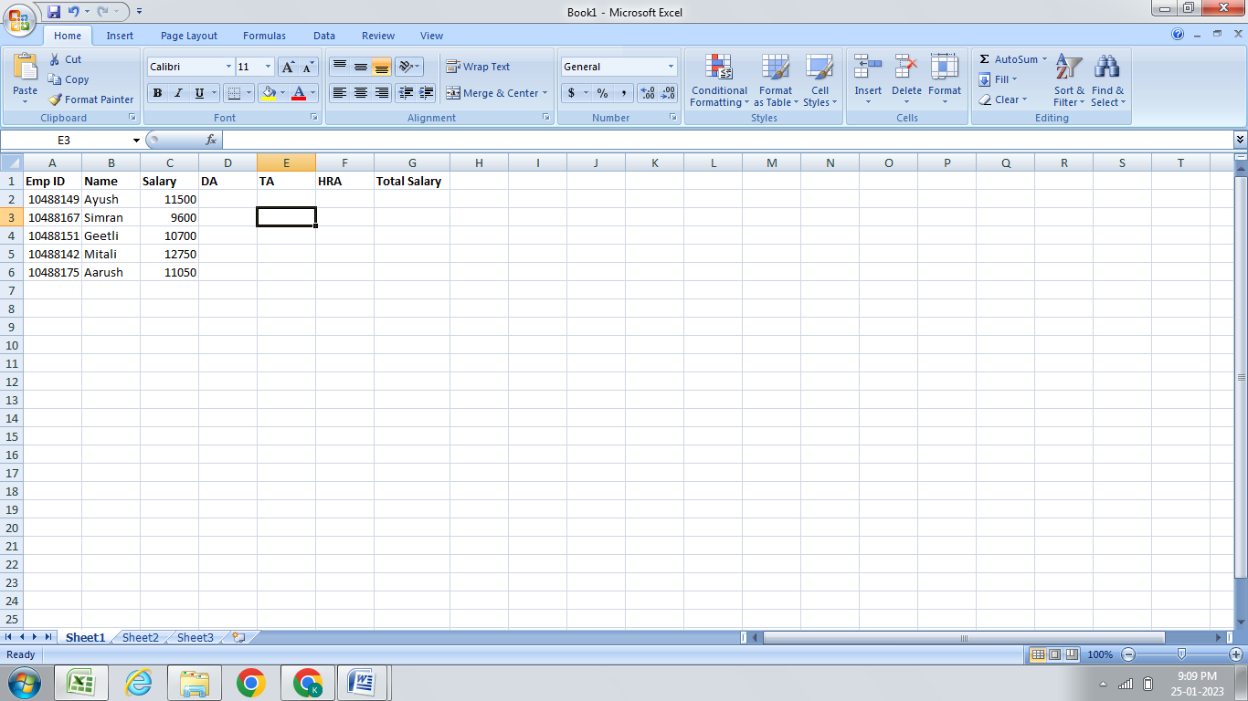
  - Calculate the DA of all the employees as 10% of their salary.
  - Calculate the TA of all the employees as 15% of their salary.
  - Calculate the HRA of all the employees as 20% of their salary.
  - Calculate the total salary by using the formula salary+DA+TA+HRA.
  - Find the maximum, minimum salaries being dispensed by this company.

